# CIELO PAYMENT GATEWAY

#### **We tried below scenarios against sandbox via POSTMAN tool. We noticed below issues.**

1. **Input Original-Json:**

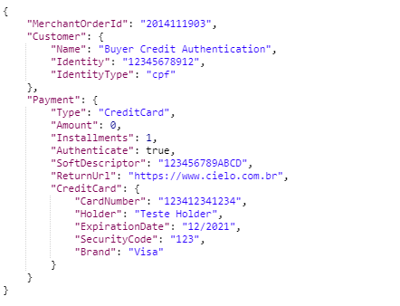

**2. Sandbox – API call (POST)**



**3. Amount Validation**

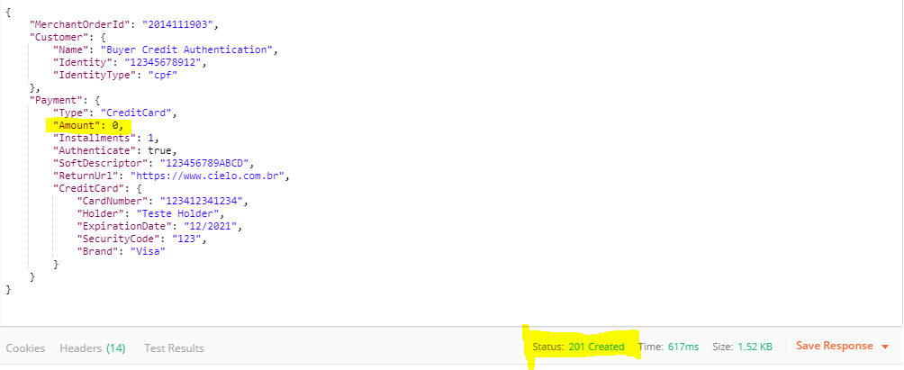

**Expected:** 

**Return Response:** **201 Created**

**4. Card-Number Validation**

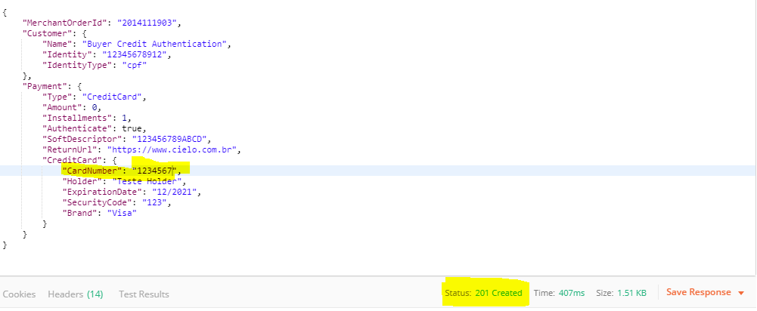

**Expected:**



**Return Response: 201 Created**

**5. Input Card-Number 12-digit’s as 0**

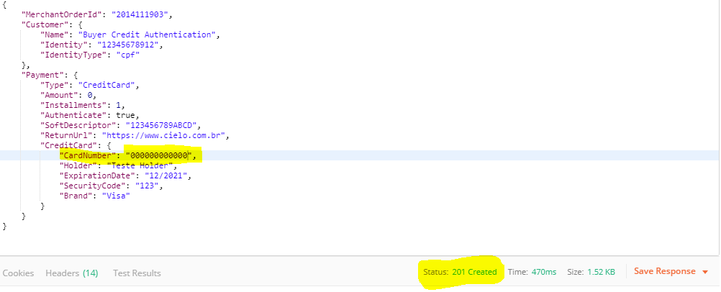

**Expected:**



**Return Response: 201 Created**

**6. Card-number input only two digits (accepted)**

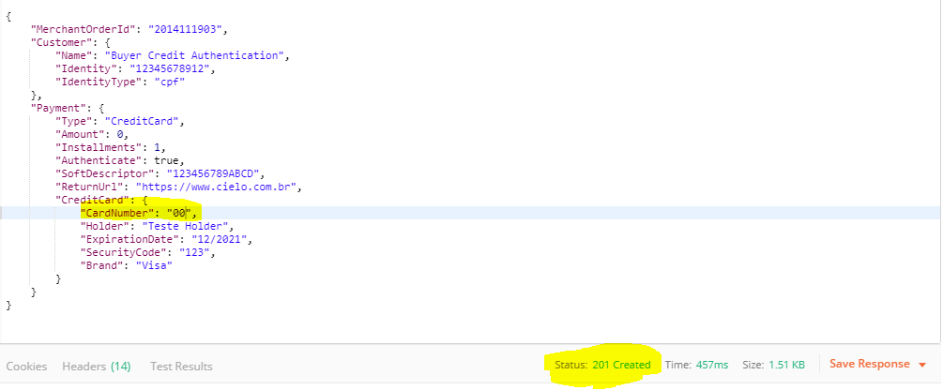

**Expected:** 

**Return Response: 201 Created**

**7. Card-Number as (* it’s accepted)**

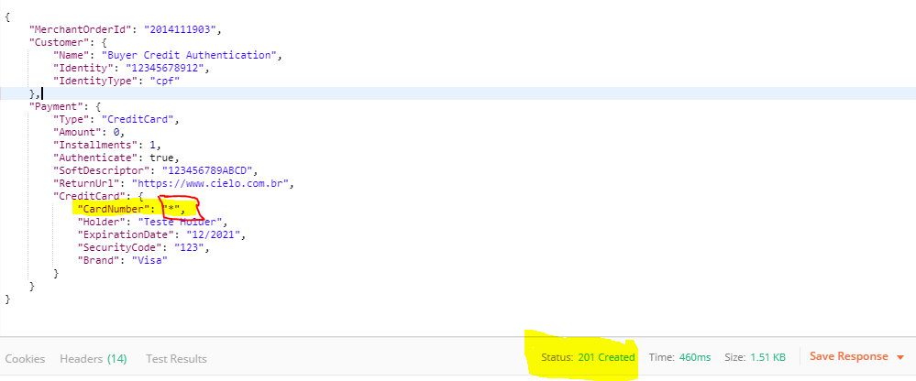

**Expected:**



**Return Response:** **201 created**

**8. CVV Number Validation (Single input value accepted)**

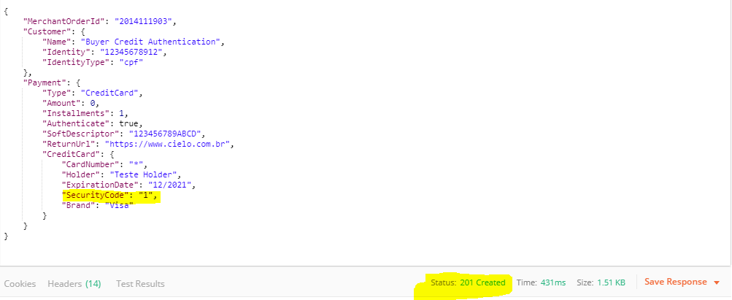

**Expected:**



**Return Response:** **201 Created**

9. **CVV Number Validation (two input value accepted)**

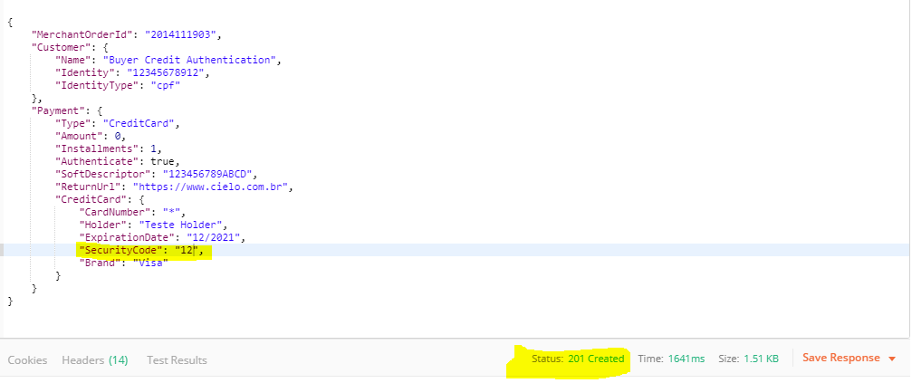

**Expected:** 

**Return Response: 201 Created**

**10. CVV Number Validation (two and three value accepted)**

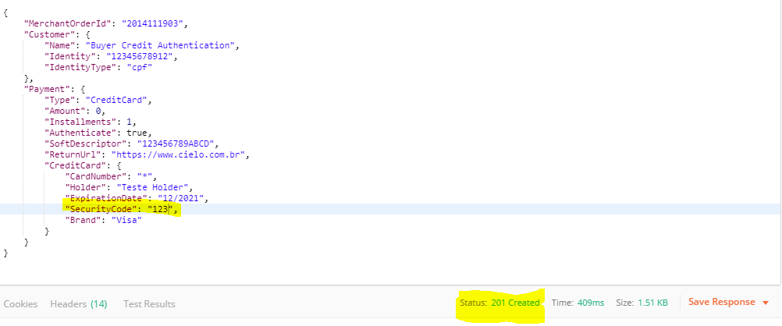

**Expected:** 

**Return Response: 201 Created**

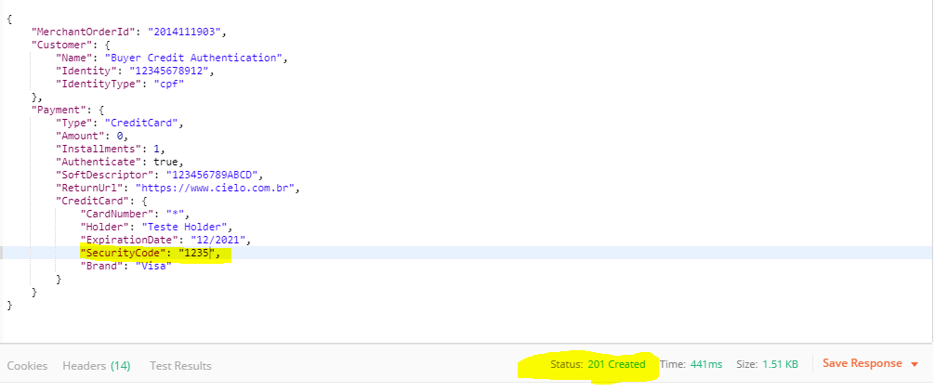

**Expected:** 

**Return Response: 201 Created**

**11. CVV Number (*) also accepted**

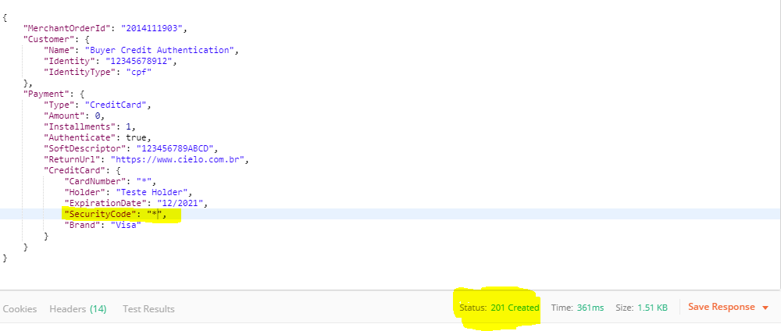

**Expected:** 

**Return Response: 201 Created**

**12. Card Number accept (Alphabetical letter’s)**

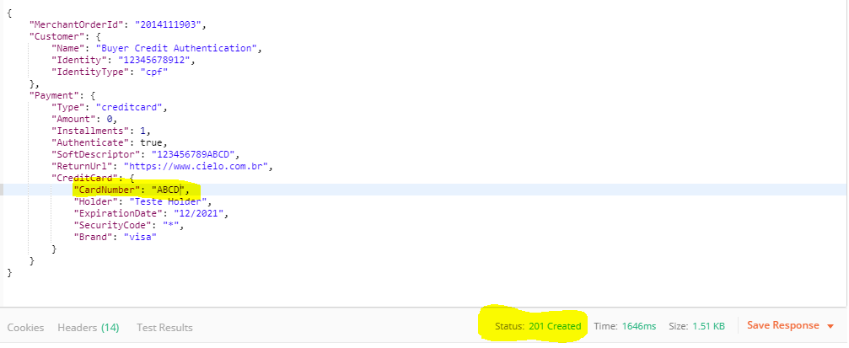

**Expected:** 

**Return Response: 201 Created**

**13. Card Number (mixed Integer & Letter’s) accepted**

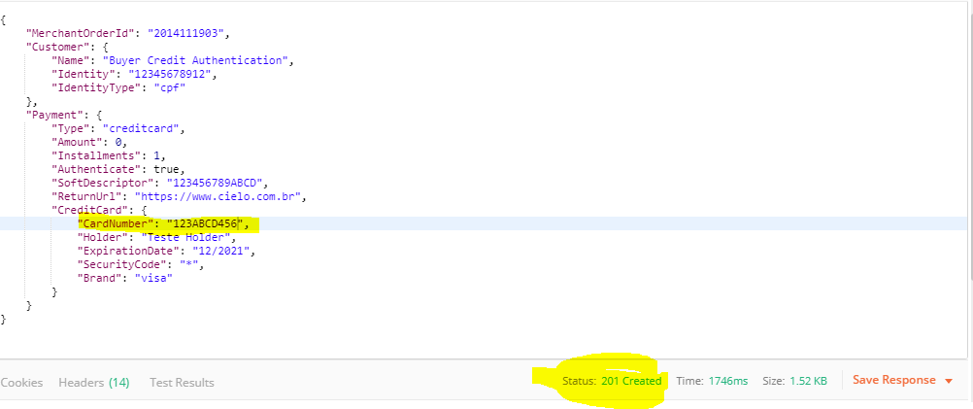

**Expected:** 

**Return Response: 201 Created**

**14. CVV Number (Alphabetical letter) Accepted**

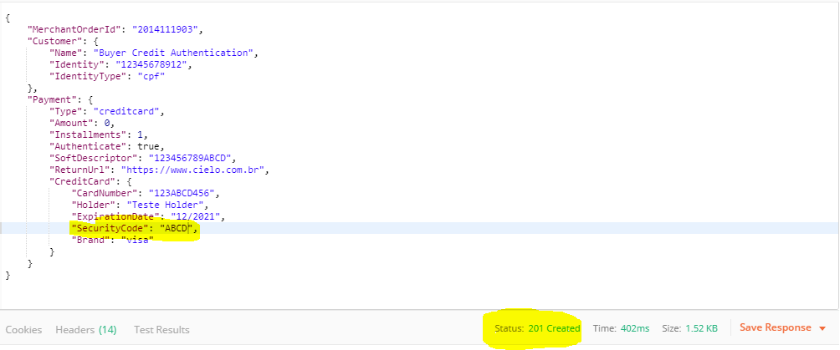

**Expected:** 

**Return Response: 201 Created**

**15. CVV Number (mixed integer’s & Alphabetical letters) Accepted**

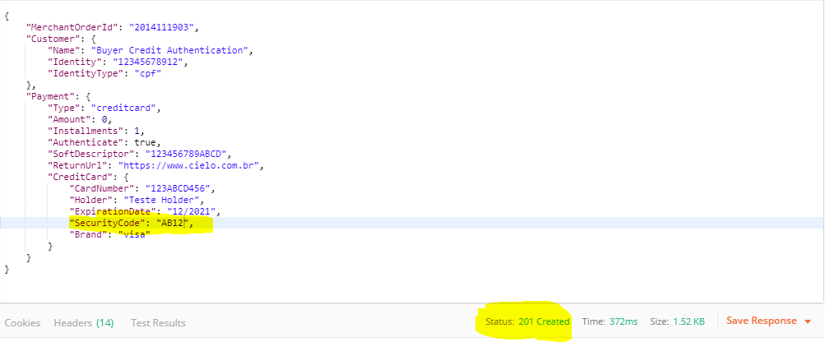

**Expected:** 

**Return Response: 201 Created**

**16. Card Holder name**

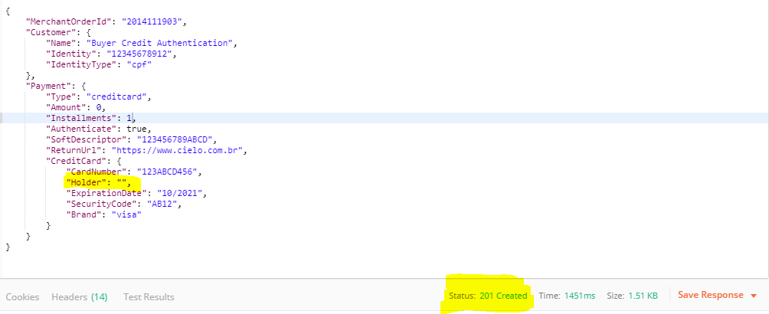

**Expected:** 

**Response: 201 Created**

**17. Installments Count**

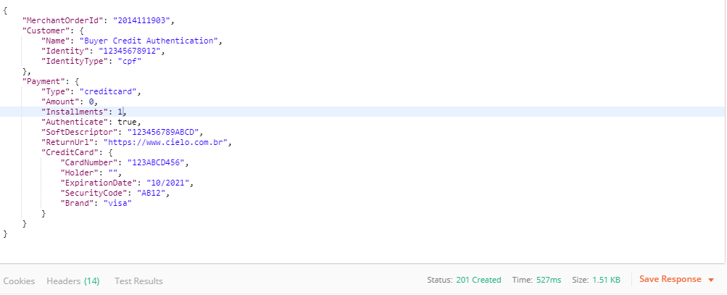

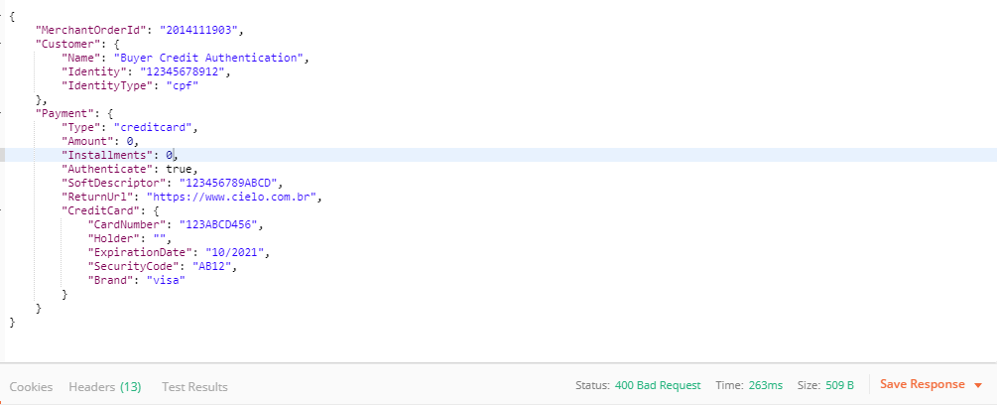

**Expected:**



**Return Response: 201 Created**